Q1.

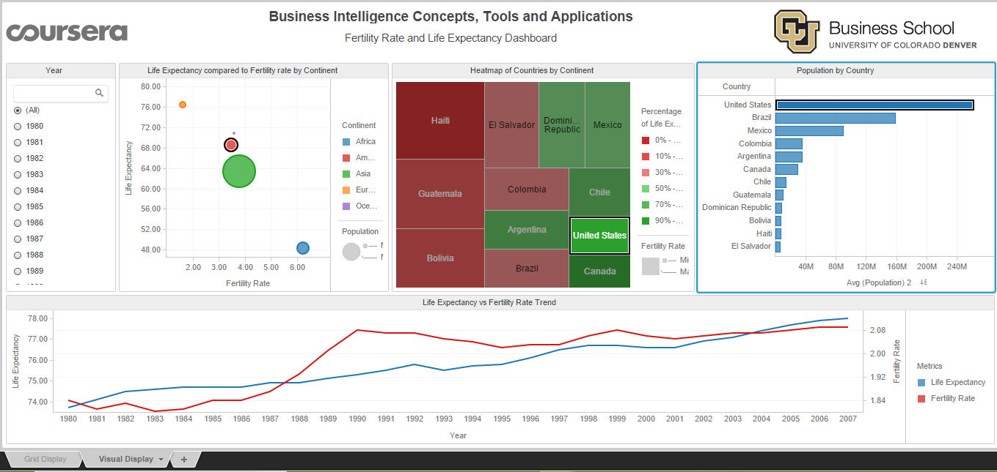

United States shows increase in fertility rate and life expectancy

Q2.

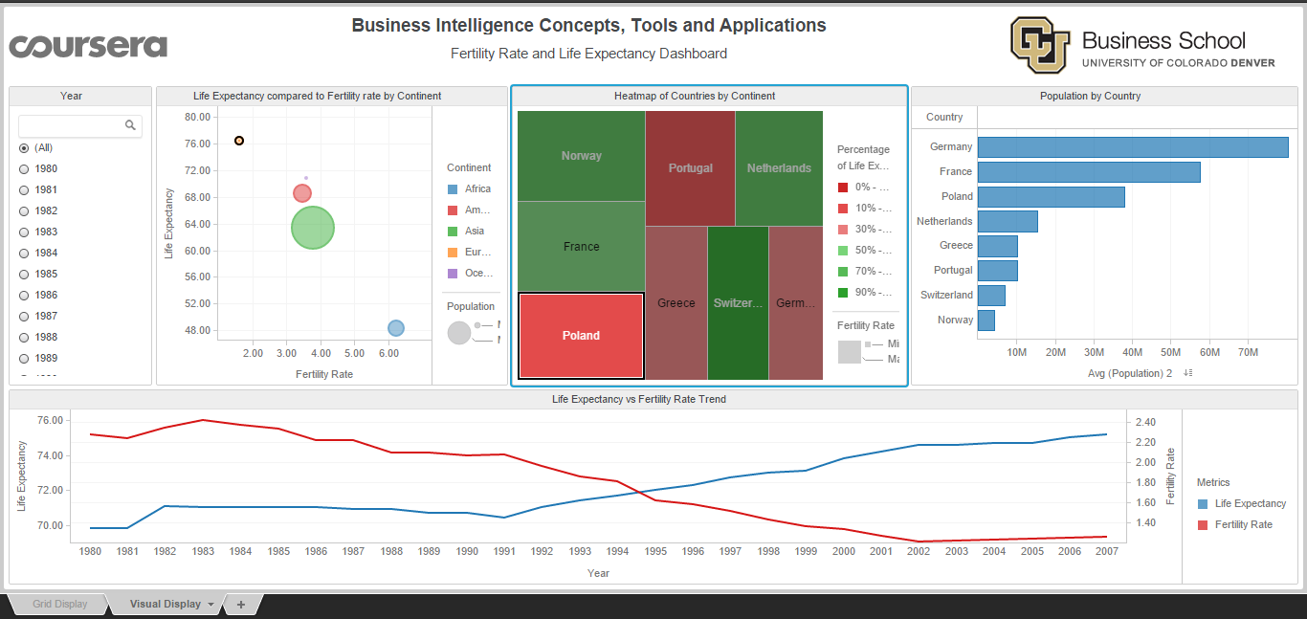

Poland had the highest fertility rate for the continent in 1980, but gradually changed to have the lowest fertility rate.

Q3.

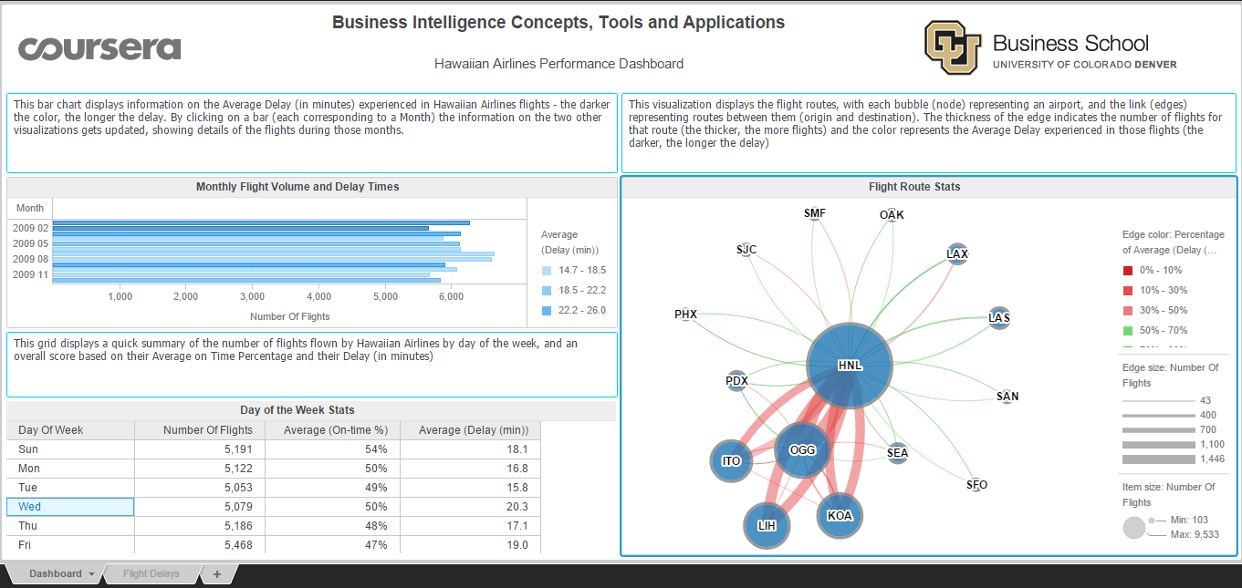

Confidence level is 45% and flights should buffer atleast 14 min.

Q4. 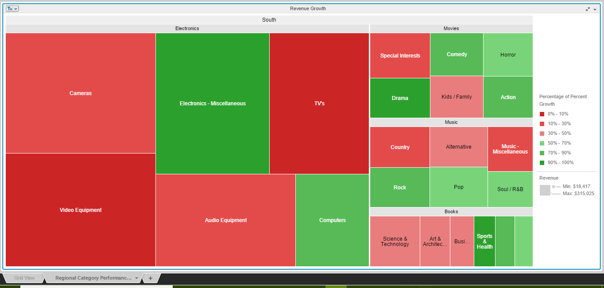

Electronics is the biggest selling category with revenue of about $1.4M

Q5.

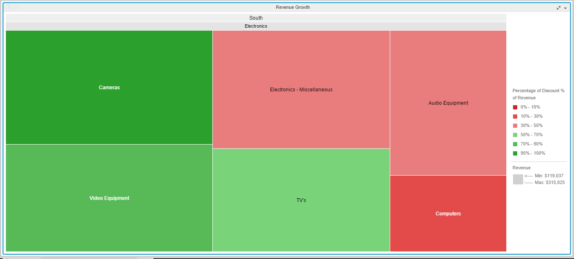

*The Discount % of Revenue seems to be too high for Cameras compared to other subcategories which is not contributing to the overall Profit Margin on these Subcategories either.*